EBS VOLUMES
- Stands for Elastic Block Store
- It is a network drive that can be attached to your instances while they run.
- It allows your instances to persist data, even after their termination. Hence, we can recreate an instance and mount the same EBS volume to that instance.
- EBS volumes can be mounted to only one instance at a time.
- EBS volumes are bound to a specific availability zone (AZ). This means, the EBS volume created in, say, us-east-1a can’t be attached to an instance created in us-east-1b.
EBS VOLUME:
- It’s a network device (not a physical drive)
  - It uses the network to communicate the instance, so there could be a bit of latency
  - It can be detached from an EC2 instance and attached to another quickly.
- It’s locked to an availability zone (AZ)
  - An EBS volume in us-east-1a cannot be attached to us-east-1b
  - To move a volume across, you first need to snapshot it.
- Have a provisioned capacity (size in GBs, an Input Output Per Second IOPS)
  - You get billed for all the provisioned capacity
  - You can increase the capacity of the drive overtime
NOTE: One EBS volume cannot be attached to multiple instances, however, multiple EBS volumes can be attached to the same instance. We can create an EBS volume and leave that unattached but can be used on-demand.
One instance can have multiple EBS volumes, but one EBS Volume cannot be attached to multiple instances
US-EAST-1
US-EAST-2
EBS
EBS
EBS
EBS
Unattached EBS

EC2
EC2
EC2

By default, the delete on termination checkbox is ticked, which means whenever an EC2 instance is terminated, the EBS volume will also get terminated.
To check the EBS Volumes attached to the Instance:
- Login to the AWS Console and go to your instances under Instances.
- Select the instance and go to the Storage tab. Here, it will show the EBS volume attached to it.
NOTE: We can the view the availability zone (AZ) attached to an instances under the Networking tab. This should be checked before launching an EBS Volume since the instance and the EBS volume should be in the same AZ.
Once the volume is created, its status will change from “Creating” to “Available”.

To attach the EBS Volume to an instance:
- Navigate to the EBS volume and select it.
- Go to Actions on the top right, click on Attach Volume and select the instance. Now the EBS Volume is attached to the instance.
- We can cross verify if the volume is attached to the instance or not, by going back to the instance and looking for the EBS volumes under the Storage tab.
NOTE: If you create an EBS Volume in an AZ and try to attach it to an instance in another AZ, it won’t allow us as it won’t show any instance available in that AZ.
Delete on termination option for an instance is selected when an instance is being launched. If selected Yes, the EBS volume will be deleted once the instance is terminated and if selected No, even if the instance is terminated, the EBS volume will still not be deleted.
The non-deleted EBS volume will still be available under EBS Volume tab and could be attached to other instances.

EBS SNAPSHOTS
- Make a backup (snapshot) of your EBS Volume at a point of time.
- If you want to recover the deleted EBS Volume, we can do it so using EBS Snapshots. Hence, snapshots are helpful if you want to recover deleted EBS Volumes.
- It is not necessary to detach the volume to do the snapshot, however, it is recommended.
- Snapshots can be copied across AZs or Region. This would be helpful to transfer data to different regions or AZ from one region or AZ.
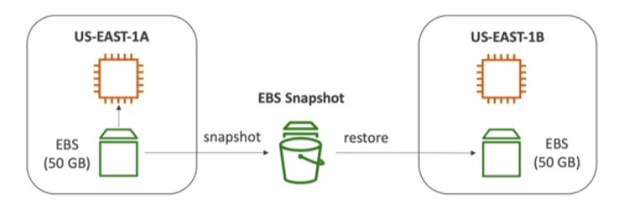

EBS Snapshots Feature:
- EBS Snapshot Archive
1.1. Move a snapshot to an “archive tier” that is 75% cheaper
1.2. Takes within 24 to 72 hours for restoring the archive
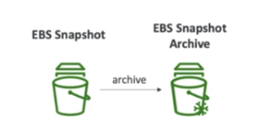
- Recycle Bin for EBS Snapshot
2.1. Setup rules to retain deleted snapshots so you can recover them after an accidental deletion
2.2. Specify Retention (from 1 day to 1 year)
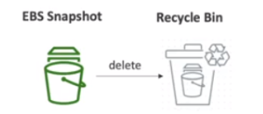
To take the snapshot of an EBS Volume:
- Go to the EBS Volume section and select the volume.
- On the top right, under Actions, click on Create Snapshot.
- Give the description and then click on Create. The snapshot of this volume will be created.
- Once the volume is created, the Snapshot option will be enabled under EBS Volume section.
- You can also copy the snapshot to some other region by right clicking on the snapshot, and selecting the appropriate region.
- There is also an option to create Volume from the snapshot, available under Actions.
- It is always better to create a Recycle Bin retention rule and apply it to the features so that in case the Volumes (in this case) is deleted acidentally, we should be in a position to recover it.
- Go to Snapshot -> Recycle Bin (on the top right) and create the rule.
- Once created, now if the volume is deleted, the resource will be moved to recycle bin. We can recover the same from recycle bin.

